Assignment 5  
Code:

%{  
#include <stdio.h>  
%}  
  
number [0-9]+  
  
%%  
{number} {printf("%x ", atoi(yytext));};  
. {printf("Not a number. ");};  
%%  
  
int yywrap()  
{  
return 1;  
}  
  
int main()  
{  
yylex();  
return 0;  
}

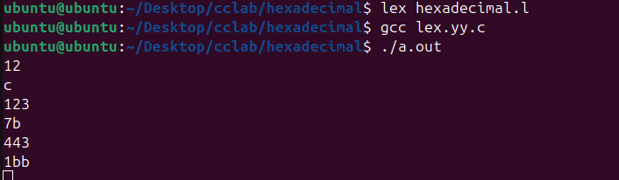

Code-File version

%{  
#include <stdio.h>  
%}  
  
number [0-9]+  
  
%%  
{number} {fprintf(yyout, "%x", atoi(yytext));};  
. {fprintf(yyout, "%s", yytext);};  
%%  
  
int yywrap()  
{  
return 1;  
}  
  
int main(int argc, char *argv[])  
{  
if (argc != 3) {  
fprintf(stderr, "Insufficient arguments! Usage: %s <input_file> <output_file>\n", argv[0]);  
return 1;  
}  
  
yyin = fopen(argv[1], "r");  
if (!yyin) {  
fprintf(stderr, "Unable to open input file: %s\n", argv[1]);  
return 1;  
}  
yyout = fopen(argv[2], "w");  
if (!yyout) {  
fprintf(stderr, "Unable to open output file: %s\n", argv[2]);  
return 1;  
}  
yylex();  
fclose(yyin);  
fclose(yyout);  
return 0;  
}

